B Tree Deletion
https://www.cs.usfca.edu/~galles/visualization/BTree.html
E.g. of initial state : m = 5
Minimum number of keys values = m / 2 child = 2.5 child = 2 key
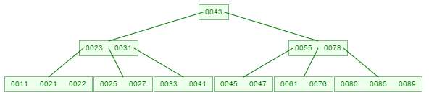
Like insertion, deletion is also done from the leaf nodes. There are two cases of deletion.
- First, a leaf node has to be deleted.
E,g, : -11, -89, -25, -76, -27, -61
- Second, an internal node has to be deleted.
E.g : -23, -43, -78 from initial state
Steps involved in deleting a leaf node.
- Locate the leaf node which has to be deleted.
- If the leaf node contains more than minimum number of key values (more than m/2 elements), then delete the value. E.g. : -11, -89
-11
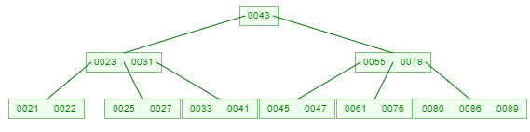
-89
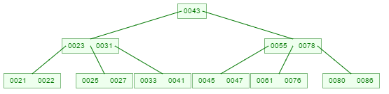
- Else, If the leaf node does not contain even m/2 elements, then fill the node by taking an element either from the left or from the right sibling.
  - If the left sibling has more than the minimum number of key values (elements), push its largest key into its parent node and pull down the intervening element from the parent node to the leaf node where the key is deleted. E.g. : -25 from initial state

Initial state :
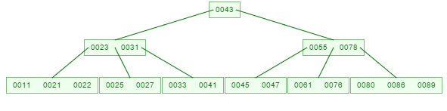
-25
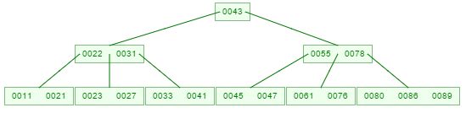

  - Else, if the right siblings has more than the minimum number of key values (elements), push its smallest key into its parent node and pull down the intervening element from the parent node to the leaf node where key is deleted. E.g. : -76 from initial state

-76
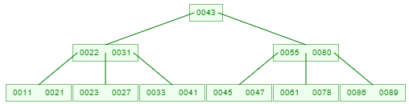

- Else, If both left and right siblings contain only the minimum number of elements, then create a new leaf node by combining the two leaf nodes and the intervening element of the parent node (ensuring the the number of elements do not exceed the maximum number of elements a node can have, that is, m).

Note : If pulling the intervening element from the parent node leaves it with less than the minimum number of keys in the node, then propagate the process upwards, thereby reducing the height of the B-Tree.

E.g. :
- 27

-61


Steps involved in deleting an internal node.
To delete an internal node, promote the successor or predecessor of the key to be deleted to occupy the position of the deleted key. This predecessor will always be in the leaf node. So the processing will be done as if a value from the leaf node has been deleted.
E.g : from initial state -23, -78, -43,

Initial state :

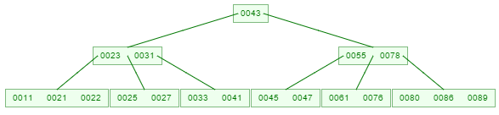

-23
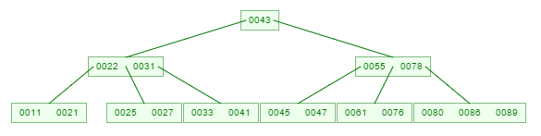

-78
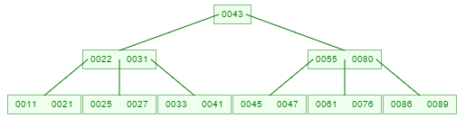

Another Example of Internal Node Deletion E.g :
From
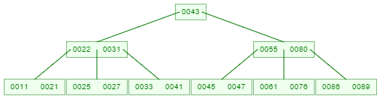
-31
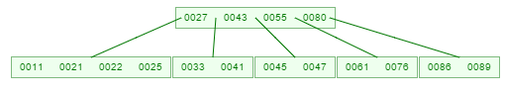

From

-55
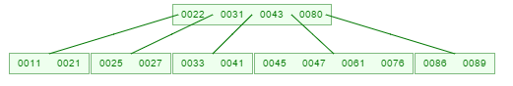
From


-43

-45
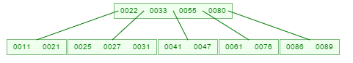
-80
